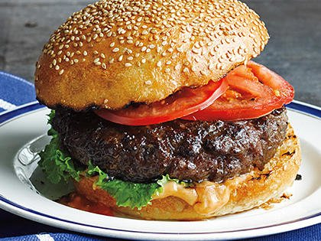
Best Ever Juicy Burgers
Prep Time 10 min Cook Time 10 min
8 servings
Ingredients
½ cup mayonnaise
½ cup plain dry breadcrumbs
1 envelope onion soup mix
1 egg per Grandma Jachimowski
2 pounds ground beef or ground turkey
8 hamburger buns

Directions
- Combine mayonnaise, breadcrumbs, egg and soup mix in bowl.
- Mix mayonnaise mixture into ground beef. Shape into 8 patties.
- Grill or broil until done. Serve burgers on buns.
Notes
For a delicious creamy barbecue sauce topping, combine 1/4 cup BBQ sauce with 1/2 cup Hellmann's. Spoon on juicy burgers and enjoy!

